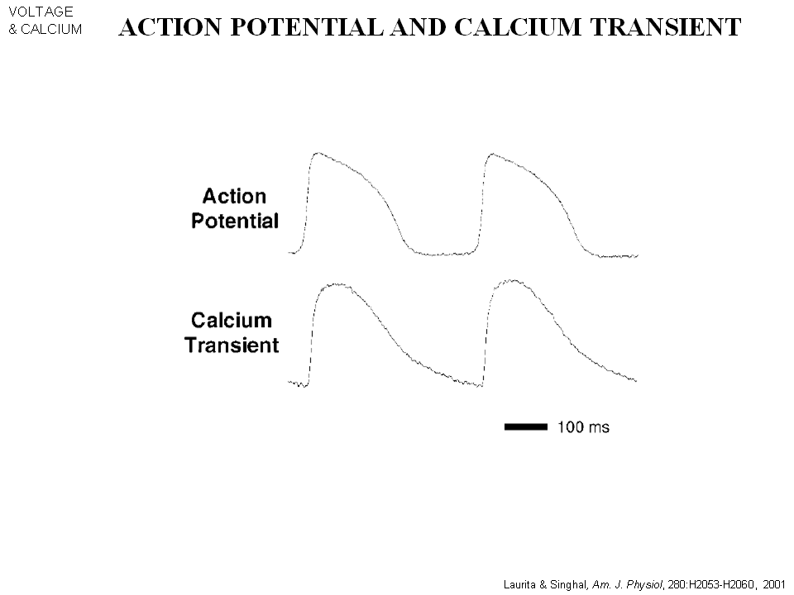

If measure the action potential and internal calcium concentration simultaneously.
- The increase of Ca++ due to the internal store of SR ( in the beginning)
- during the action potential to the end of action potential the level of Ca++ in the cell drops. The level of Ca++ in the cell drops, because its pump back to SR to prime the SR. (To be high concentration and ne prepare for the next beat.
- It’s the Ca+ ion that bind to troponin that start the contraction.
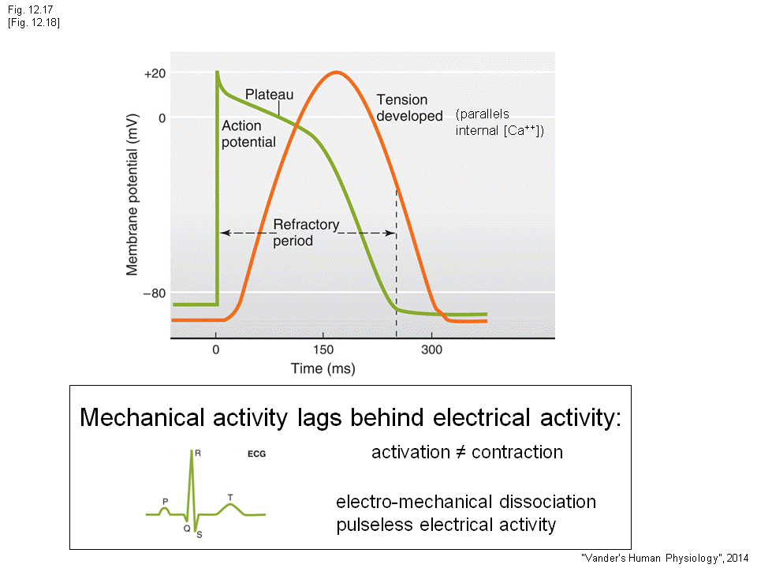
The tension of the force that is develop will look similar to the internal calcium concentration curve (due to it’s the Ca+ ion that bind to troponin that start the contraction.)
- The force start to increase (the contraction starts
- Reaches max
- Relaxation of the cell of the heart
- Excitation contraction coupling is what’s coupling to take action potential as signal and use tension develop as result
- Do not confuse the excitation with contraction
- Everything we see on the ECG is electrical, you need the electoral signal first and then the contraction.
- Dramatic example :Electo- mechanical dissociation (PEA = pulseless electrical activity) : this patient when look at ECG, the QRS complex do exist, but the patient don’t have aby pulse . The action potential does spread to the ventricle, QRS complex is good but no contraction. This is the break down of excitation contraction coupling. (No contraction )
- If ask: look at the QRS complex, and said this is the ventricular contraction: wrong! This is the indication the depolarization wave pass through the heart .

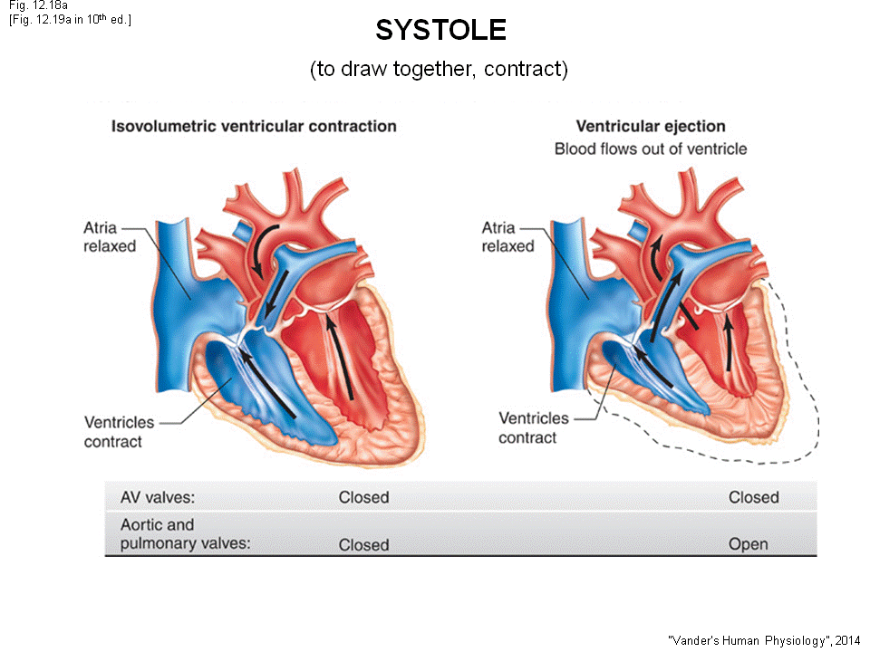

That’s come back to the cardiac cycle.
- The entire cycle can be broke up to two pieces.
- systole (ventricle contract)
- diastole(ventricle not contract)
- When say systole refer to ventricle systole. If talking about atrium, need to point out atrial systole.
- Ventricle contract. Almost immediately, when Ventricle contract, the atrial-ventricle vale will close.
- At the very start of the contraction of the ventricle, the atrial-ventricle vale is open
- The pressure of ventricle starts to go up, shortly the pressure of ventricle will exceed the pressure in atrium. the valve will close (the left diagram)
- The Aortic/Pulmonary valve are closed, now when the Av VALVE CLOSED. BOTH VALVE IS CLOSED
- If look at the left ventricle, the aortic valve is closed. The right –pulmonary valve.
- Now the ventricle is contracting. The Av valve is closed at the start of contraction the, the pressure keep increasing. When the pressure reach a certain point.
- The aortic valve will open, as well as the pulmonary valve. (The AV valve is still closed)
- Ejection! The blood is ejected into the lungs and the body
- The ventricle contract some time and stop contracting at certain time
- The pressure of the ventricle drops
- At some point (pressure of the ventricle drops) The aortic and pulmonary valve will closed .
- In the very first phase when contract, both the av /pulmonary/aortic valve is closed
- The volume of ventricle is fixed and the pressure is going up. (the contraction happen called “isovolumetric ventricular contraction” phase, the pressure of the ventricle is contracting. Since both valve are closed, the chamber is a fix volume, but the pressure go up )
- When pressure high enough. Aortic/Pulmonary valve open: over this phase --- blood leave enter “ventricular ejection” phase.
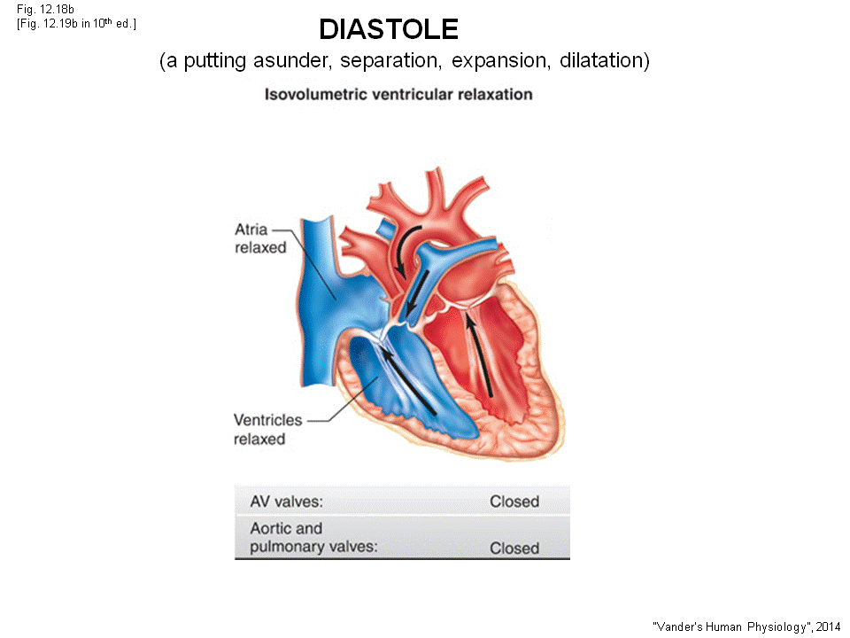
- The pressure at some point starts to go down, these valve will close. (The pressure of the ventricle is falling, both valves are close “Isovolumetric ventricular relaxation”)
- The pressure in ventricle keep falling, at some point it get lower than the atrium pressure
- The AV valve will open. (When P_{ventricle} > P_{atrium ,} AV closed, When P_{ventricle} < P_{atrium,} P atrium push the valve open, AV open)
- This phase is ventricular filling, is this valve is opened. The pressure in atrium is higher than ventricle (main reason we have blood filling) , blood will flow in to the ventricle ------diastole phase (phase of filling)
- At normal heart rate, spend of 1/3 of the systole and 2/3 diastole filling.
- For example: your heart rate is 1/sec. ==> spend 1/3 sec of contraction (systole) and 2/3 sec for diastole filling (ventricle) . Your ventricle fill because of the 2/3 per sec that AV valve is opened on both side, and the pressure in atrium is higher than ventricle. Nothing contract the heart at this moment, but the blood is flow from the atrium to ventricle. Remember there is no valve at the inlet of the atria, the blood keep comes in so the filling is in diastole phase.

- The last thing to happen is the atrial contraction: the end of diastole period, the atrium will contract. Inject a bit more blood into the ventricle
- The patient with atrial fibrillation, the atria is not pumping any blood to ventricle, but ppl can still exercise and normal. The atrial kick the extra amount of blood in to the ventricle ( not absolutely crucial)
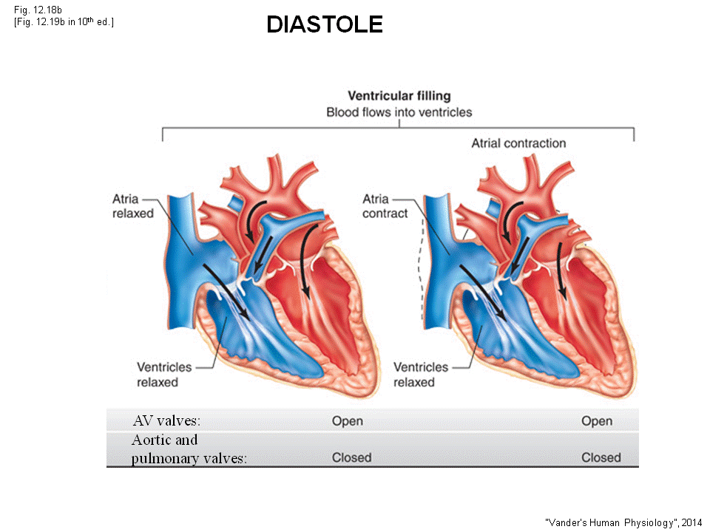

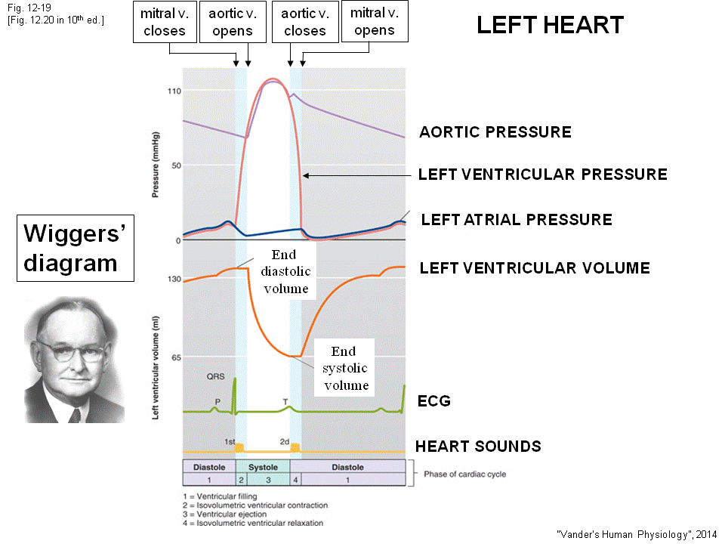
The Wigger’s diagram (a summary)
- Left heart
- The P QRS T
- The QRS here will trigger off the contraction of ventricular muscle
- During the diastole period: which pressure is higher: --the left atrial pressure is higher than the left ventricle (filling happens)
- As soon as ventricle starts to contract, the left ventricular pressure boost up (you can see very fast left ventricle pressure > left atrial pressure)
- The AV valve (mitral) open when diastole, than pressure exceed atrium mitral valve will closed
- The aortic valve is closed, this 2 valve closed phase is called “isovolumetric ventricular contraction” this pressure goes up
- The pressure in ventricle exceed aorta (on the top of pic,) The Aortic valve will open(p.s. aortic pressure fall during diastole)
- At this point of time, ventricle stop contracting : relaxation. Ventricle pressure drop down to almost zero.
- As the pressure drop , the pressure in ventricle will be lower than aortic, the valve is closed by the pressure of aorta (the cross line on pic), the ejection phase stop ( The ejection phase start when Aortic vavle open, and stop once the valve closes.)
- At this point both of the Valves are closed, but the ventricle is relaxing. “Isovolumetric ventricular relaxation”
- Finally , the ventricular pressure drop very low and below the pressure of left atrium, The AV valve will open. The filling phase.
- Thee last thing, next T wave cones along give a bit increase in left atrium, and dump the certain amount of blood into ventricle.
- The orange line is the volume of blood in ventricle. In diastole phase, the blood will increase .In T wave it dump a bit mote blood in to the ventricle.
- At the (2st blue area), the 2 valve is close, but the pressure increase. The volume is fixed and pressurize. This phase called the end diastole volume, the volume of blood = the end of diastole.
- Ejection phase, the volume drop
- Aortic valve and mitral valve are both close at (2nd blue area) , you have a fix volume of blood during the” Isovolumetric ventricular relaxation” This is the end of systole, the volume is called “End systole volume”
- Look at the ECG
- If the P wave, atrial contraction soon after
- QRS complex: upstroke of action potential take some time for Ca++ to turn on the whole process of contraction coupling to happen. Then quick rise of the pressure in ventricle.
- Eventually, the action potential will repolarize , muscle relax T wave
- Heart sound
- Generated by the closing of the valve,
- first heart sound: generated at the same time as QRS complex (This is generated by the closing of mitral valve)
At the same time the right heart is doing the same , closing of both AV valve at the same time . When both of them close == >create a noise ---first heart sound
- Second heart sound: Aortic /pulmonary valve closes. The closing generate the second heart sound.
- This diagram is important!!!

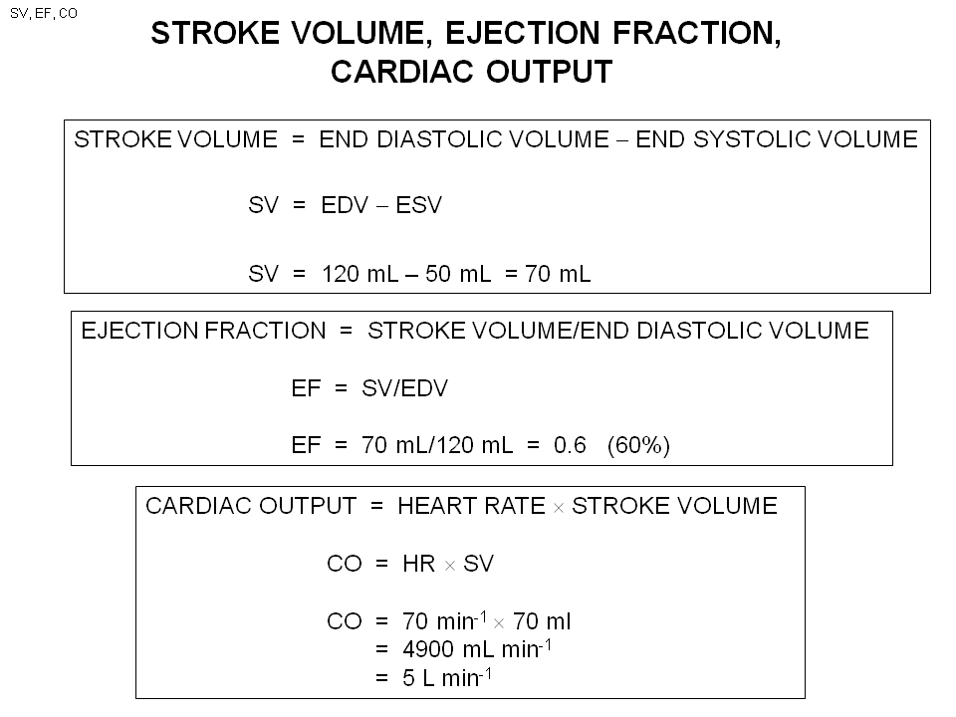
Stroke volume = the amount of blood that is ejected by the ventricle on each heart beat
Stroke volume =(the blood you have in the beginning) – (end of contraction) = the number of volume that is ejected
Typical SV= 70ml (memorize

Ejection fraction is important for ppl with heart attack and hear failure
EF = The fraction of blood that is ejected by ventricle
= (the number of volume ejected = SV) / (what you start with = End diastole volume)
Normal person = 60%

Cardiac output = 5l /min (memorize )
= 60~70 contraction in that minute * SV( the ejection)
= 5L.

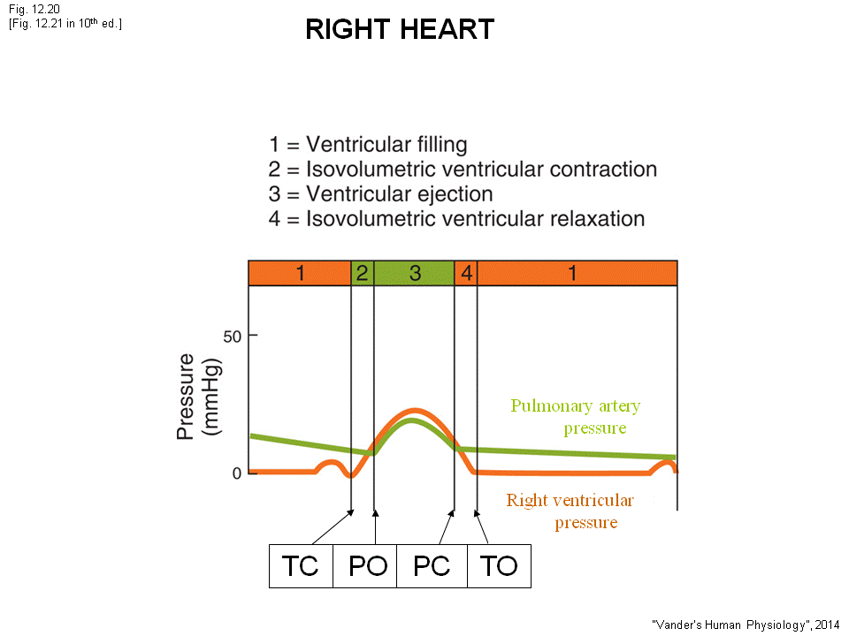
- recall the cross section of right ventricle is much thinner muscle than left ventricle. the right ventricle have a smaller pressure generation.
- The peak of ventricular pressure in left = 120mmHg
- The peak of ventricular pressure on the right = 20mmHg
- In diastole phase , the pulmonary pressure is falling
- The right ventricular pressure increase
- At some point , the right ventricular pressure is higher than pulmonary pressure.
- – exactly same as before
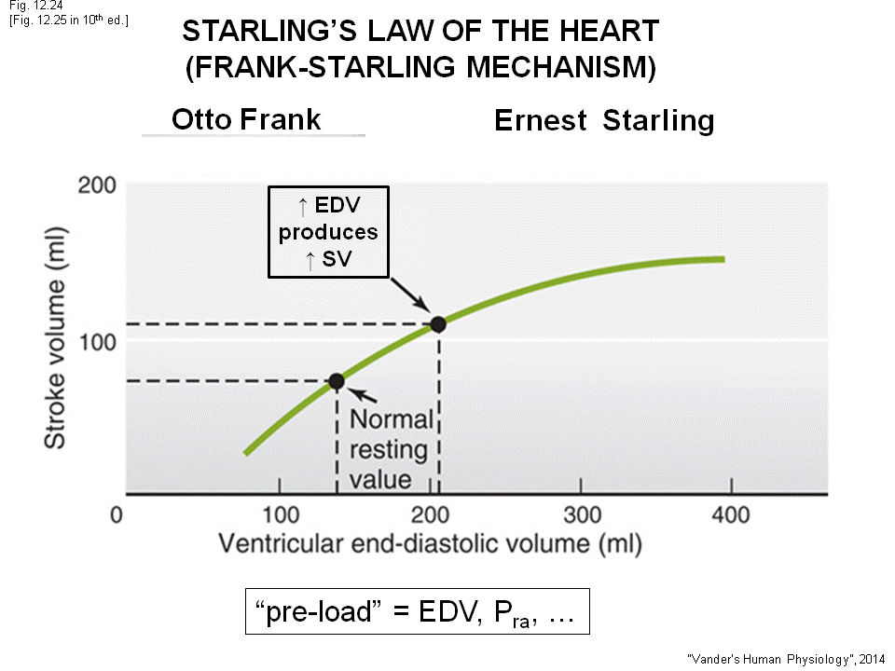
- Key: The peak interventricular pressure generate by right heart is only 20mmHg. But The cardiac out put of both heart is the same!
Starling’s law of the heart
- If fill the ventricle more before contraction .The end diastole volume is going up. - On the X-axis, is the end diastolic volume
- Assume: end diastolic volume = 140 ml, Sv= 70ml. If now fill more ( ex: exercising , more blood to atrium, ventricle.)The amount of fluid is now higher, the wall of the ventricle is stretch. The cardiac muscle will contract more forcefully is the muscle is stretch more.
- Fill the heart more, the force of contraction is greater, and the amount of blood eject will be greater stroke volume will go up (eject more blood)
- Starling law’s :Increase the end diastolic volume, the stroke volume will goes up
- When exercise, return more blood to the heart , stretch heart, force contraction increase ,pump more blood out
- In muscle: The amount of stretch before contraction is called the preload. (stretch more ---increase the preload) . So increase the end diastolic volume, is increasing the preload. The greater the preload the stronger the contraction is.
- So the end diastolic is used as the index of preload.
- Why would the pressure of right atrium be the index of preload?
- The pressure difference of atrium and ventricle is what drive the blood to the ventricle, so if the atrium pressure goes up , the flow to ventricle will be more. So the end diastolic volume will be higher more stretch preload

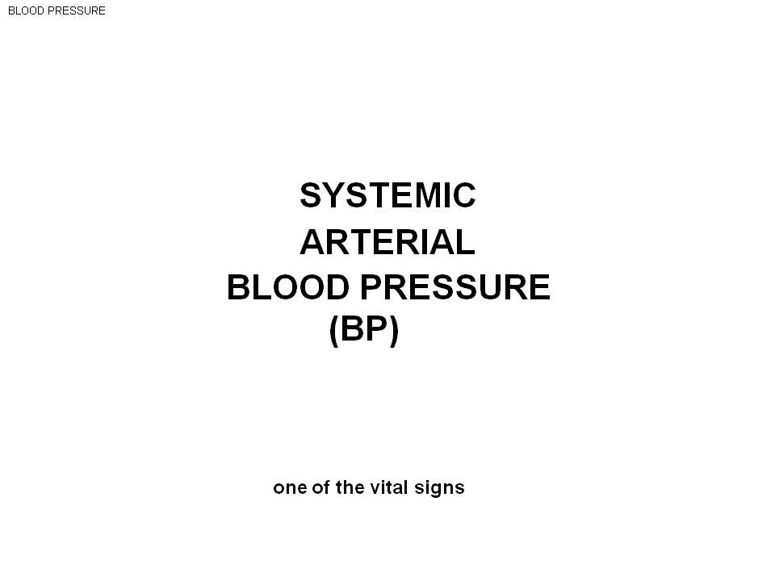

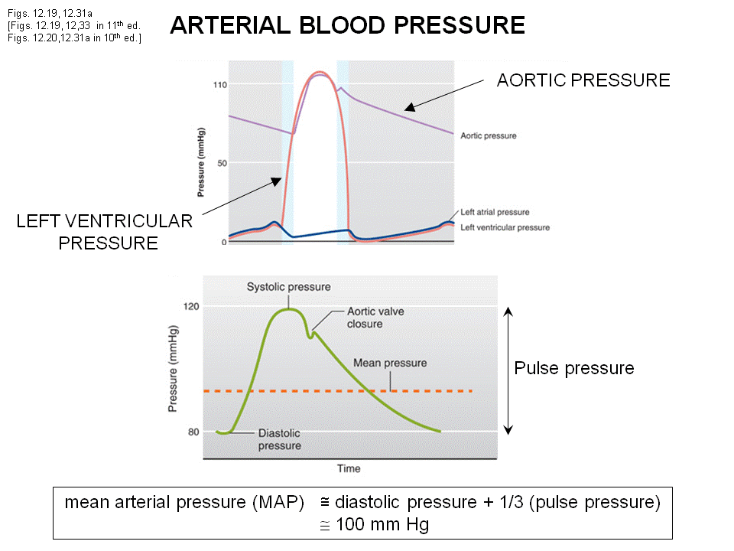
Here we are showing BP – systemic arterial blood pressure
- Aorta: during the diastolic phase the pressure will fall . The ventricle give a pressure a kick up at every heart beat.
- If this is your last heart beat, The Bp wull decline to almost 0.
- The pressure is by the valve opens up, ejection phase the pressure is kick up generate the blood pressure
- There are 4 numbers
- The max: systolic pressure (at the top of both diagram )
- The min :diastolic pressure: The pressure falls off through diastolic phase and at the point before the pressure kick up.
- Pulse pressure Systolic and diastolic pressure difference
- The mean (average ) pressure :this is the pressure change in time . (This is the pressure to use to give a constant flow ) = min +(1/3) max
- This patient have 120mmHg/80 mmHg pressure
- Systolic: 120 diastolic : 80 mmHg
- Pulse pressure 120 – 80 =40
- Average : 100 mmHg (This is why we say the typical mean blood pressure is about 100 mmHg) (memorize )


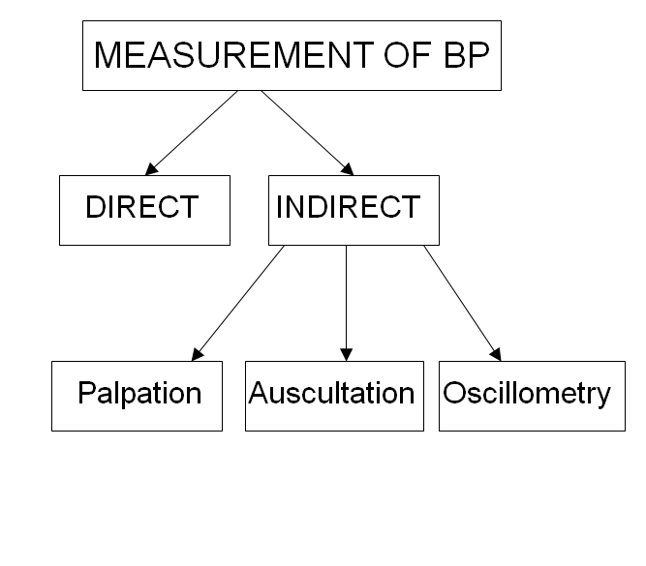
Direct method: use the catheter into artery…like the pic
Or use catheter to measure but instead of tube use voltage to measure.
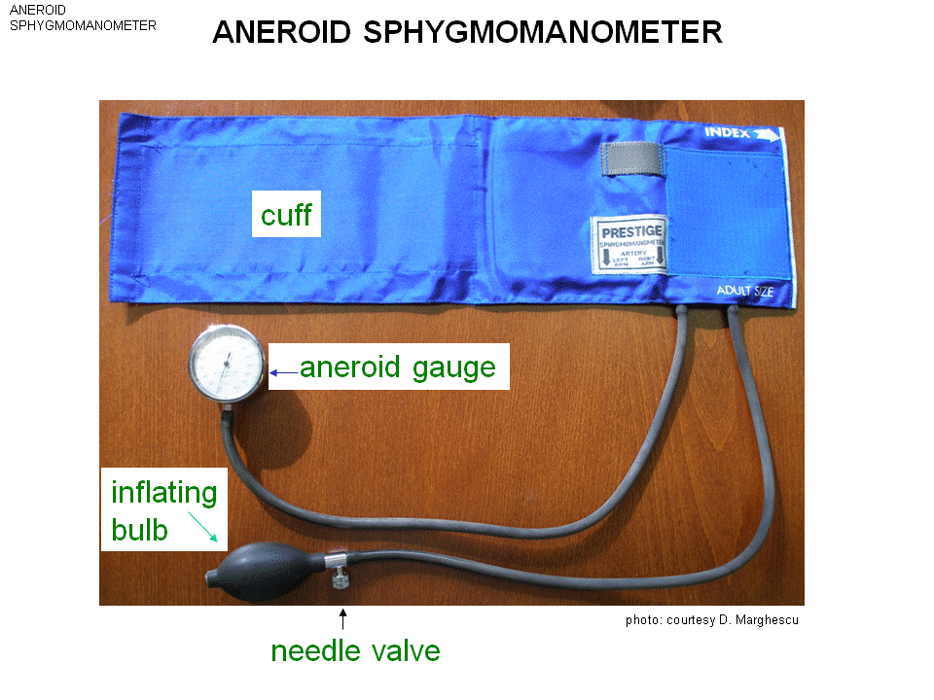
Indirect method: 3 method

A cuff – a blood pressure cuff – this is holo, use a inflating bulb to inject air into the cuff to increase the pressure into the cuff.
A gauge to replace the mmHg –measure the pressure in the cuff
This is a BP cuff (aneroid sphygmanometer ) – use a a (no )neroid (fluid) gauge


This is all you need for method of palpation, put this on the arm.
- Measure the big artery
- Put the cuff on, and inflate to high volume.
- The wall artery is flexible, high pressure outside will close the artery. When Pcuff > P systolic artery close the artery. There will be no pulse in the artery.

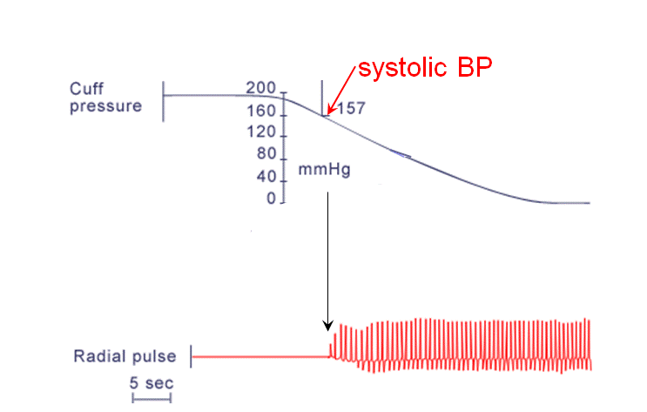
- You turn the cuff to a higher pressure then systolic Bp.
- Now turn a valve (hole) , the air in cuff will leak out.
- The pressure in cuff will fall
- As pressure in the cuff drop , at some point , you will fell the regular pulse (P cuff <P artery artery open, blood through, pulse appear)
- This patient the pulse happen when cuff = 157 mmHg = systolic BP

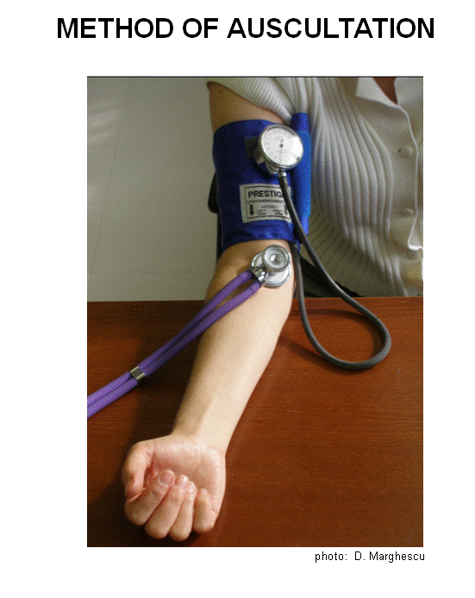
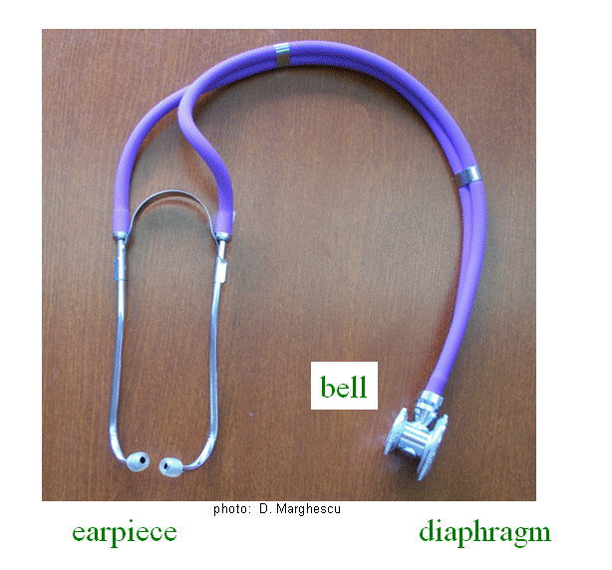
The second method: auscultation
- To listen blood pressure sound
- When no cuff apply – smooth flow , no sound
- Put the cuff on, with high pressure close artery blood flow hear nothing
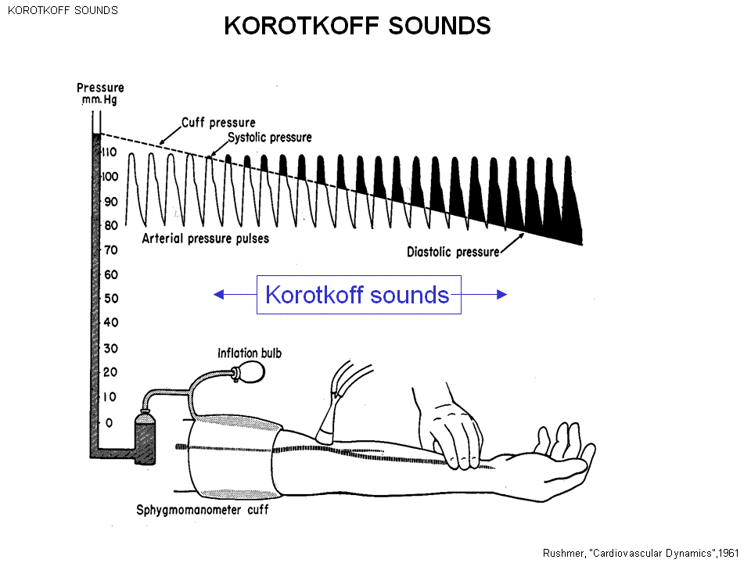
- Now lower the blood pressure
- At the point when the cuff is lower than systolic pressure artery will open a small, a little blood through(artery partially open) . That blood is at a high speed and make a high noise you first hear a sound.
- Call the blood pressure sound or Korotkoff sound
- As the pressure in the cuf keep falling the artery open up more ,you keep hearing the sound. Finally when the cuff pressure = diastolic pressure , the artery back to the normal size no sound ( back to the normal state—laminar fluid )
- First hear sound: Systolic pressure. Stop hear a sound: Diastolic pressure
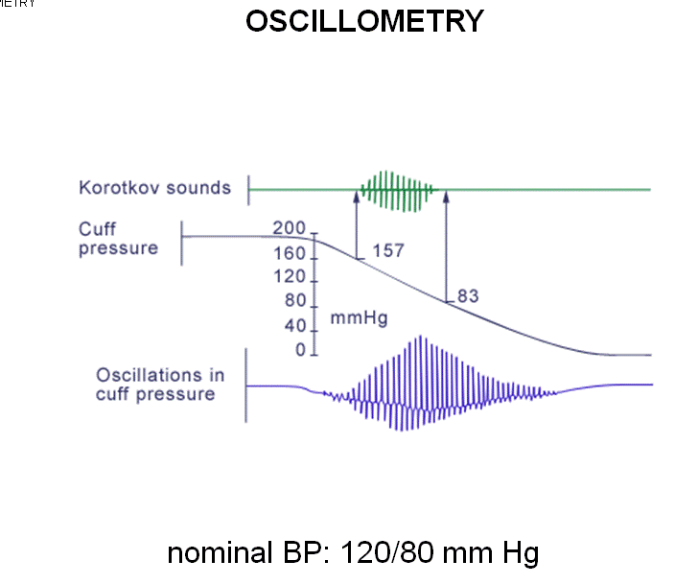
Note these are not heart sounds but the blood pressure sound.
- Out cuff on, the machine inflate and deflate the cuff
- We measure the pressure of he cuff
- As the cuff pressure is lower, the machine will pump the pressure to high pressure and will open a hole to let the air go and drop cuff pressure
- Before hearing the korotkov sound, there is a oscillation in cuff pressure
- The computer make calculation and tell the systolic and diastolic
- This don’t involve the sound but the fluctuation inside the cuff.

